Date: 24.04.2024

Urgent Field Safety Notice

VARIOUS MAPLESON F ANAESTHETIC BREATHING SYSTEMS CONTAINING 0.5L RESERVOIR BAGS WITH OPEN TAILS

For Attention of*: MDSO’s, All clinical staff, Managers and users of the above product

Contact details of local representative (name, e-mail, telephone, address etc.)*

Giedrius Budrys
Customer Resolution and Relationship Manager
Intersurgical UAB
Arnioniu str 60, LT-18170 Pabrade Lithuania

Email: giedriusb@intersurgical.lt
Tel. +370 387 66611
Fax: +370 387 66622

or

This could be a distributor or local branch of the manufacturer. To be added at the appropriate stage in the different local languages

Urgent Field Safety Notice (FSN)

VARIOUS MAPLESON F ANAESTHETIC BREATHING SYSTEMS CONTAINING 0.5L RESERVOIR BAGS WITH OPEN TAILS

Risk addressed by FSN

- Information on Affected Devices*
1. | - Device Type(s)*
 | Various Mapleson F Anaesthetic Breathing Systems
1. | - Commercial name(s)
Mapleson F infant T-piece breathing system with 0.5L open tail bag, ≥ 1.8m
Mapleson F Jackson Rees modification T-piece breathing system with 0.5L open tail bag, ≥ 1.8m
Paediatric, Mapleson F Jackson Rees modification T-piece with 0.5L open tail bag, and swivel elbow, ≥ 1.8m
Paediatric, Mapleson F Jackson Rees modification T-piece with 0.5L open tail bag, and swivel elbow, ≥ 4.8m
Paediatric, Mapleson F Jackson Rees modification T-piece with 0.5L open tail bag, and elbow, ≥ 2.8m
Paediatric, Mapleson F Jackson Rees modification T-piece with 0.5L open tail bag, and elbow, ≥ 1.8m
Paediatric, Mapleson F Jackson Rees modification T-piece with 0.5L open tail bag, and swivel elbow, ≥ 3.6m
Paediatric, Mapleson F Jackson Rees modification T-piece with 0.5L open tail bag, and luer elbow, ≥ 3.6m
Map/F 0.5L Open T/B Luer/Elb >= 2.4m
Map/F 0.5L Open T/B Luer/Elb M/Line >= 1.8m
Map/F 0.5L Open T/B Luer/Elb >= 1.6m
Paediatric, Mapleson F Jackson Rees modification T-piece with 0.5L open tail bag, and luer elbow, ≥ 10.8m

1. | - Unique Device Identifier(s) (UDI-DI)
5030267062249 5030267062270 5030267062362 5030267062430 5030267103164
5030267062256 5030267062287 5030267062379 5030267062508 5030267149810
5030267062263 5030267062348 5030267062393 5030267062539

 | - Primary clinical purpose of device(s)*
 | To deliver and remove anaesthetic and respiratory gases to and from a paediatric patient via a breathing system comprised of tubing and connectors and 0.5 L reservoir bag.
1. | - Device Model/Catalogue/part number(s)*  2120000, 2121000, 2121002, 2121004, 2121005, 2121011, 2121014, 2121019, 2121024, 2121035, 2121042, 2121045, 2121048, 2121053
1. | - Software version
 | N/A
1. | - Affected serial or lot number range  Any of the above with an expiry date from April 2024 to March 2029.
1. | - Associated devices
 | N/A.

- Reason for Field Safety Corrective Action (FSCA)*
2. | - Description of the product problem*
Some devices contain a reservoir bag with a closed tail, when they should have a reservoir bag with open tail.

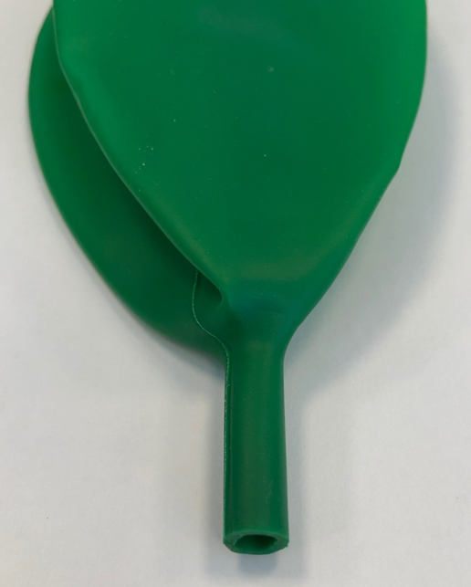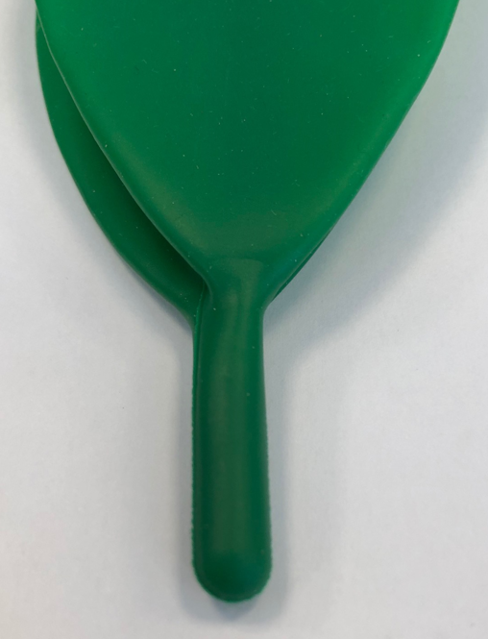
Correct – Open Tail Reservoir Bag Incorrect – Closed Tail Reservoir Bag

2. | - Hazard giving rise to the FSCA*
 | If the incorrect closed tail reservoir bag is not identified during the routine pre use check as described in the product instruction for use, it could result in over pressurisation of the system leading to potential barotrauma.
2. | 3. Probability of problem arising
 | 100% in the affected range.
2. | - Predicted risk to patient/users
 | The risks associated with the identified fault have been reviewed, and whilst the probability of occurrence is low, we believe it is essential to address the issue promptly to further reduce the risk of any potential patient harm.
2. | - Further information to help characterise the problem
 | N/A
2. | - Background on Issue
 | Following a customer report from the market and subsequent thorough inspection and analysis of internal stock, we have identified a potential safety concern related to various Mapleson F paediatric anaesthetic breathing systems as listed above. Unfortunately some products have been manufactured with a 0.5 L reservoir bag with a closed tail which could result in over pressurisation of the system.
2. | - Other information relevant to FSCA  N/A
 | - Type of Action to mitigate the risk*
3. | - Action To Be Taken by the User*  ☒ Identify Device ☐ Quarantine Device ☐ Return Device ☐ Destroy Device  ☐ On-site device modification/inspection  ☐ Follow patient management recommendations  ☒ Take note of amendment/reinforcement of Instructions For Use (IFU)  ☒ Other ☐ None  Please distribute this Field Safety Notice to all potential users of the Mapleson F paediatric anaesthetic breathing systems listed above, within your facility. This is for their awareness of the potential problem and to carry out the following actions.  To ensure the safety of patients we recommend the following actions.  1. Identify any potentially affected products from the affected codes and lot numbers listed above.  2. All users must perform a thorough visual inspection and functional test before use of the products and lot numbers listed above, to confirm a patent gas pathway exists through the open tail of the reservoir bag to avoid over pressurisation of the system.  3. Retain any affected sample(s) identified, and please report to us immediately.  Please note: This is not a product removal.  Please complete and return the Reply Form provided to giedriusb@intersurgical.lt (local contact e-mail address), to confirm receipt of this notice and that the necessary actions are being taken.  Please continue to report to Intersurgical any adverse events involving this product.
3. | - By when should the action be completed? | Immediately on receipt of this FSN, and awareness of this FSN should be ongoing until all potentially affected stock listed in this FSN has been used up.
3. | - Particular considerations for: N/A  Is follow-up of patients or review of patients’ previous results recommended?  Not applicable.
3. | - Is customer Reply Required? *  (If yes, form attached specifying deadline for return) |  | Yes
3. | - Action Being Taken by the Manufacturer  ☐ Product Removal ☐ On-site device modification/inspection  ☐ Software upgrade ☒ IFU or labelling change  ☒ Other ☐ None  We have implemented corrective actions in manufacturing process to eliminate this problem for future supply. We will also be introducing a new instruction for use which will include the following Pre-Use Check in line with the recommended action 2. above:  If the product is supplied without an APL valve, the pressure within the system is controlled by the clinician through manipulation of the open tail on the reservoir bag. Check that a patent gas pathway exists through the open tail of the reservoir bag.
3 | - By when should the action be completed? | One month from receipt of the FSN
3. | - Is the FSN required to be communicated to the patient /lay user? |  | No
3 | - If yes, has manufacturer provided additional information suitable for the patient/lay user in a patient/lay or non-professional user information letter/sheet?
 | N/A

 | - General Information*
4. | - FSN Type* | New – Advisory Notice
4. | - For updated FSN, reference number and date of previous FSN | N/A
4. | - For Updated FSN, key new information as follows:
 | N/A
4. | - Further advice or information already expected in follow-up FSN? * | No
4 | - If follow-up FSN expected, what is the further advice expected to relate to:
 | N/A
4 | - Anticipated timescale for follow-up FSN | N/A
4. | - Manufacturer information  (For contact details of local representative refer to page 1 of this FSN)
 | - Company Name | Intersurgical Ltd.
 | - Address | Crane House, Molly Millars Lane, Wokingham, Berkshire, RG41 2RZ
 | - Website address | https://www.intersurgical.com/
4. | - The Competent (Regulatory) Authority of your country has been informed about this communication to customers. *
4. | - List of attachments/appendices: | Customer Reply Form
4. | - Name/Signature | Ivan Seniut, Group Quality and Regulatory Affairs Director, Intersurgical
 | Transmission of this Field Safety Notice
This notice needs to be passed on all those who need to be aware within your organisation or to any organisation where the potentially affected devices have been transferred. (As appropriate)

Please transfer this notice to other organisations on which this action has an impact. (As appropriate)

Please maintain awareness on this notice and resulting action for an appropriate period to ensure effectiveness of the corrective action.

Please report all device-related incidents to the manufacturer, distributor or local representative, and the national Competent Authority if appropriate, as this provides important feedback.

Note: Fields indicated by * are considered necessary for all FSNs. Others are optional.

