URGENT Field Safety Notice UPDATE
Trilogy Evo, Trilogy Evo O2, and Trilogy EV300

<Date of letter deployment> <date format: DD-MMM-YYYY, e.g. 02-JAN-2021>

To: Name / Title / Customer Name
Street Address
City, State, Zip Code

This document contains important information for the continued safe and proper use of your equipment.

Please review the following information with all members of your staff who need to be aware of the contents of this communication. It is important to understand the implications of this communication.

Please retain this letter for your records.

[Insert consignee name],

As previously communicated to the market through Field Safety Notifications (FSNs), this letter is to inform you of the release of a mandatory Software update Version 1.06.10.00 and a User Manual addendum for the Trilogy Evo, Trilogy Evo O2, and the Trilogy EV300 ventilators. These updates resolve the safety issues outlined in Section 1 below and in appendix A. In addition, the software update and User Manual addendum will also address other non-safety related issues not previously communicated, which are outlined in appendices B and C. Please note that any corrections resolved in previous software updates are included in this software update. All devices are required to be updated to version 1.06.10.00. Please review this letter in its entirety, as some information may be new or updated from what was previously communicated.

For further information on the issues resolved by these updates, please refer to the following appendices:

- Appendix A: Safety related issues previously communicated through FSNs
- Appendix B: Non-safety related issues not previously communicated to the market.
- Appendix C: Miscellaneous Updates Included in SW 1.06.10.00

For instructions on how to download the software update, please refer to the following appendices:

- Appendix D: Software Update Procedure for DME/Homecare Users (MyP4P)
- Appendix E: Software Update Procedure for Hospital Users (InCenter)

- What the problem is and under what circumstances it can occur
Please refer to appendix A, where full information on the previously published FSNs for each of the following issues were communicated:

- Environmental Contamination of Device Sensor (2023-CC-SRC-003):
Product(s) affected: Trilogy Evo, Trilogy Evo O2, and Trilogy EV300
Originally communicated April 2023

- Battery Depleted or Loss of Power Alarms Triggered (2024-CC-SRC-001):
Product(s) affected: Trilogy Evo, Trilogy Evo O2, and Trilogy EV300
Originally communicated February 2024

- Incomplete Contraindications Statement (2023-CC-SRC-011):
Product(s) affected: Trilogy Evo, Trilogy Evo O2, and EV300
Originally communicated November 2023

Philips Respironics is taking the opportunity of the software update and User Manual addendum described in this communication to also address additional non-safety related issues which have not previously been conveyed to the market. Please refer to appendix B, where full information on these issues is provided.

- Hazard/harm associated with the issue.
There are no new health hazards associated with the introduction of this new software. Please refer to appendix A for health hazards identified for the specific issues being resolved by this mandatory software update.

- Affected products and how to identify them.

Trilogy Evo, Trilogy Evo O2, and Trilogy EV300 models could be impacted by one or more of the issues described in this letter. To identify the model of your equipment, refer to the part number on the bottom of the device:

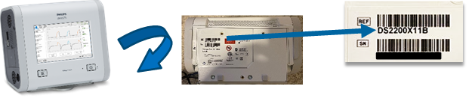

- Actions that should be taken to prevent risks for patients or users.

- Please communicate this updated Urgent Field Safety Notice Update to all who need to be aware within your organization, or to any organization where the potentially affected devices have been transferred. Distributors should identify customer list and where appropriate, distribute this Field Safety Notification and all relevant appendices to physicians, clinicians, patients and/or users.

- Review the information in appendix A and B to familiarize yourself with the issues and ensure you follow the recommended mitigations provided in this letter until the software update is completed. All software-related issues communicated within this letter are resolved with the release of Software Version 1.06.10.00.

- To prevent unnecessary risk for patients, immediately update the device software following the instructions provided in this letter and refer to the User Manual addendum provided. Philips Respironics will be following up with customers to ensure devices have been updated to SW version 1.06.10.00.

For DME/Homecare users:
The software is available via the “My Philips for Professionals” website for customers to update devices. Please refer to Appendix D for instructions on how to download the software correction.

For Hospital users:
The software is available via InCenter. Please refer to Appendix E for instructions on how to download the software correction.

<For markets which require the software update to be delivered in a different manner, such as USB, please update the instructions above and in the Appendices as necessary.>

- Actions planned by Philips to correct the problem.

Philips is releasing this mandatory software update, version 1.06.10.00, and a User Manual addendum to resolve all software-related issues and labeling-related issues detailed in this communication.

Please be assured that maintaining a high level of safety and quality is our highest priority.
If you need any further information or support concerning this issue, please contact your local Philips representative. <Philips representative contact details to be completed by the Market/Business>

This notice has been reported to the appropriate Regulatory Agencies.

Sincerely,
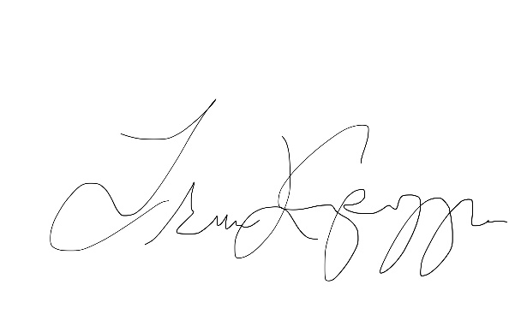
Tracie Capozzio
Sr. Director, Head of Quality Therapy Platforms
Sleep and Respiratory Care

URGENT Field Safety Notice Response Form
Reference: Trilogy Evo, Trilogy Evo O2, and Trilogy EV300 Update
Instructions: Please complete and return this form to Philips Respironics promptly and no later than 30 days from receipt. Completing this form confirms receipt of the Urgent Field Safety Notice letter, understanding of the issue, and required actions to be taken. Please note that this form must be completed, even if you have already submitted a response form for the previously communicated issues included in this letter.

This Response Form serves as acknowledgment of all issues identified in this Field Safety Notice.
Customer/Consignee/Facility Name:
Street Address:
City/State/ZIP/Country:

Customer Actions:
- Read this Urgent Field Safety Notice and update the software of all impacted devices in accordance with the software update instructions.
- Please return the completed form using the contact indicated below or email it to [localization] within 30 business days of receipt.
- In addition, please find attached the list of impacted serial numbers. Please inform us of the serial numbers which have been updated with the referenced software once completed.

We acknowledge receipt and understanding of the accompanying Urgent Field Safety Notice letter and confirm that the information from this letter has been properly distributed to all users that handle the Trilogy Evo, Trilogy Evo O2, and Trilogy EV300 ventilators.

Name of person completing this form:
Signature:
Printed Name:
Title:
Telephone Number:
Email Address:
Date (DD / MMM / YYYY):

<provide instructions here for the customer regarding returning the form to Philips, e.g. fax #, email address. For example, “Please fax this completed form to Philips at (xxx)xxx-xxxx>

Appendix A
Safety related issues previously communicated through FSNs

Software-Related Issues
This section provides details of software-related issues that have been previously communicated. These issues have been resolved by Software Update 1.06.10.00. Please refer to Appendix D and E for instructions on installing the software update.

- Battery Depleted or Loss of Power Alarms Triggered (2024-CC-SRC-001)
Product(s) affected: Trilogy Evo, Trilogy Evo O2, and Trilogy EV300
Originally communicated February 2024

The problem and the circumstances under which it can occur:
A software algorithm that calculates remaining battery life can malfunction and cause the device to either:
- Issue a Loss of Power alarm that stops CPAP or PSV therapy while operating on battery power alone.
- Issue a Battery Depleted alarm while continuing therapy if plugged into a permanent power source, such as AC or DC power.

This can only happen if all of the following conditions are met:
- The device is operating in CPAP or PSV mode
- The device is not able to detect the respiratory effort of the patient for at least ten minutes and fifty-five seconds

Patients most vulnerable to this issue include neonatal and pediatric patients, patients recently removed from anesthesia, or other patients with low inspiratory effort due to their potential for minimally detectable respiratory effort.

This malfunction is due to a software algorithm calculation error and is not a malfunction of the internal or detachable batteries. An alarm, which can stop therapy, may occur even if there is sufficient battery life remaining.

This malfunction will not happen in ventilation modes other than CPAP and PSV.

Hazard/harm associated with this issue
A Loss of Power event can cause irreversible harm to the most vulnerable patient populations, including death, if the associated alarm is not observed with the appropriate response. This is because the Loss of Power alarm will cause CPAP or PSV therapy to stop while the high priority alarm alerts the care provider to the issue.

Actions that should be taken in order to prevent risks for patients or users
Until the software update is installed, your device(s) may continue to be used safely in CPAP or PSV mode for all users if all safety measures are followed:
- Ensure the Backup Ventilation is set to ON and the apnea interval setting is correct and appropriate based on the clinical assessment of the patient. This will minimize the chances for a CPAP or PSV supported patient to encounter a loss of power malfunction.
- Keep the device plugged into AC or DC power to the greatest extent possible.
- Keep an alternative form of ventilation on standby. If the device must be unplugged for patient transport, plug the device back in as soon as you reach your destination.
- Do not leave a patient unsupervised while operating on battery power alone.
- Follow typical monitoring protocols for ventilated patients such as use of backup monitors, including pulse oximetry or heart rate.

Immediately plug the device into a power source if a Loss of Power alarm occurs. This includes AC power, DC power, or installing a fully charged detachable battery. If none of these power sources are available, then remove the detachable battery and put it back in. Each of these will clear the alarm and restart the ventilator.

Please note that you may have received previous communication to update your device to software version 1.06.06.00. While version 1.06.06.00 resolves the loss of power alarm issue, the software update being communicated in this letter (1.06.10.00) resolves this issue as well as the other issues described. Software version 1.06.10.00 should be applied to all devices, even if version 1.06.06.00 was already installed.

Labeling-Related Issues
This section provides details of labeling-related issues that have been previously communicated. Please refer to the User Manual addendum attached to this letter which corrects these labeling issues.

  - Environmental Contamination of Device Sensor (2023-CC-SRC-003):
Product(s) affected: Trilogy Evo, Trilogy Evo O2, and Trilogy EV300
Originally communicated April 2023

The problem and the circumstances under which it can occur:
Environmental debris may accumulate on the internal machine flow sensor, causing partial occlusion which may impact accurate delivery of pressure, volume, or flow.

Hazard/harm associated with this issue
Environmental debris on the surface of the machine flow sensor can affect various therapy parameters, potentially leading to barotrauma/volutrauma, hypoventilation, hypercapnia. If left unaddressed this could result in hypoxemia and potentially irreversible harm.

Actions that should be taken in order to prevent risks for patients or users
To help prevent accumulation of debris on the machine flow sensor:
- Use of the Philips approved particulate filter is now required. Please refer to the User Manual addendum for further information on use of the particulate filter. Please note that installation of the particulate filter will not require a change to therapy settings.

  - Incomplete Contraindications Statement (2023-CC-SRC-011):
Product(s) affected: Trilogy Evo, Trilogy Evo O2, and EV300
Originally communicated November 2023

The problem and the circumstances under which it can occur:
The following contraindications were either partially or fully omitted from the Clinician and/or Caregiver manuals:
- The AVAPS feature is contraindicated for patients less than 10 kg.
- The AVAPS-AE therapy mode is contraindicated for invasive use and patients less than 10 kg.

Hazard/harm associated with this issue
Use of these therapy modes on contraindicated patients may lead to barotrauma, hypoventilation/hypercapnia, and rebreathing of excessive CO₂.

Actions that should be taken in order to prevent risks for patients or users
When using the Trilogy Evo, Trilogy Evo O2, or Trilogy EV300 devices, please refer to the User Manual addendum for full contraindications, including contraindications that were previously omitted.

Appendix B
Non-safety related issues not previously communicated to the market.

Software-Related Issues
The following issues were discovered during design verification and validation activities for software version 1.06.10.00. These issues do not present new risks or hazards for users. A brief summary of these issues is provided below for awareness. Installation of 1.06.10.00 resolves the issues outlined below. Instructions for downloading the software update can be found in Appendix D and E.

  - Flow Sensor Reading Compensation
Product(s) affected: Trilogy Evo, Trilogy Evo O2, and Trilogy EV300
This issue has not been previously communicated

The problem and the circumstances under which it can occur:
There is potential for volume measurement inaccuracies due to barometric pressure compensation being inactive for 30-33 minutes after the device has been turned on from the sleep state or the device has been rebooted. During the first 30-33 mins, devices use default barometric pressure. If the actual barometric pressure at the device’s location differs greatly from the default, then the volume measurement will be inaccurate. After the initial 30-33 minutes, this issue resolves automatically by the device itself because it uses barometric pressure sensor reading.

This issue does not present any hazard/harm. No adverse events, including death or injuries, have been reported.

  - Software Alarm Errors
Product(s) affected: Trilogy Evo, Trilogy Evo O2, and Trilogy EV300
This issue has not been previously communicated

The problem and the circumstances under which it can occur:
The software has an issue in which calculated parameters can accumulate errors over time which has the potential to impact alarm triggering. This issue can cause missed or erroneous alarms. Potentially impacted alarms:
- Obstruction Alarm
- High and low tidal volume alarms when using A/C-VC mode
- Leakage Alarm
- AEV Failure Alarm

It is important to note that any accumulated error computation is reset (back to 0) if one of the following conditions occur:
- The power to the CPU is interrupted which can happen when:
  - The device enters low power sleep mode
  - The device encounters a loss of all power condition
- The alarm is reset while active

This issue does not present any hazard/harm. No adverse events, including death or injuries, have been reported.

Labeling-Related Issues
The following issue is related to labeling. Please refer to the User Manual addendum included with this letter for updated labeling to remove the Keredusy (ozone-based).

  - Keredusy (ozone-based) Disinfection Method
Product(s) affected: Trilogy Evo, Trilogy Evo O2, _{and} Trilogy EV300
This issue has not been previously communicated

The problem and the circumstances under which it can occur:
Keredusy has been removed as a disinfection method due to unknown long-term effects of this disinfection method on the device components.

This issue does not present any hazard/harm. No adverse events, including death or injuries, have been reported.

Appendix C
Miscellaneous Updates Included in SW 1.06.10.00

The following fixes are also addressed in SW version 1.06.10.00. Please note that these fixes do not impact safety.

- Update to HIP/LIP - HEP/LEP technical Alarm threshold to eliminate nuisance alarms.
- Added high priority Vent Service Required alarm criteria to detect contamination on flow sensor mesh.
- Update to address E110 Vent INOP triggered by motor stalls.
- Update to spontaneous breath percent calculation.
- Updates to floating point calculations.
- Updates to translation strings to avoid confusion for customers.
- Update to address user interface (UI) issues.
- Adjustment of maximum alarm volume setting to meet standards requirements.
- Additional fixes to address software errors, as well as data corruption and transfer of data with Care Orchestrator (CO) and Care Orchestrator Essence (COE).

Appendix D
Software Update Procedure for DME/Homecare Users

To download Software 1.06.10.00 for DME/Homecare users, please follow the instructions below.
Note: MyP4P is not compatible with Internet Explorer. Access MyP4P using Microsoft Edge, Chrome, or Firefox browsers.

If you have not previously created an account on My Philips for Professionals (MyP4P), you will need to register before downloading software version 1.06.10.00. For any issues regarding the registration process for MyP4P, please contact respironics.service.operations@philips.com.

For new users:
To get started with MyP4P, you will need to register. The following instructions will guide you through the process.

Use the following link to register
Registration | Philips

- To begin, you will need to provide Personal Information and Organization information. You will need to click on each box, fill out the required fields, and click save for each section.

- If information is completed accurately, green check marks will appear. Click submit to complete the registration request.

- Once your registration is approved, you will receive an email with instructions to activate your account.

- Next, you will need to create a password. If information is completed accurately, green check marks will appear. Click submit.

- Once the password has been submitted, you can click on the link to MyP4P to choose your SRC groups (this will determine what types of documents you will have access to.

- First, you will choose your specialty – you will need to choose Sleep Therapy and Respiratory Care.

- Next, you will choose your groups. Choose the SRC groups.

- You will click on the Request Access hyperlink for each group you desire access. Then you will be prompted to enter your account number. For the Service Software group, you will need to open the ULA first and then check the box before you can click to request access.

- As you request access, a banner will appear at the top letting you know a request has been sent for you to receive access to the group.

- When you are approved for the group(s) you signed up for, you will receive a confirmation email.

This section will outline the steps to download the latest software using a USB stick:

- Download of Software from MyP4P website
Note: MyP4P is not compatible with Internet Explorer. Access MyP4P using Microsoft Edge, Chrome, or Firefox browsers.

- Log onto https://www.my.philips.com/ with your customer account and password.

- Click on the Group Documents tab.

- Use the search tool and type: Trilogy Evo, Trilogy Evo O2, Trilogy EV300.
Note: Filters can also be used to narrow the search by product and/or document type.

- Click on the applicable software version update (1.06.10.00). Read the description to be sure you are permitted to download the particular software revision.

- The file will automatically download.
Note: the file is in a compressed format (.zip).

- Downloading Trilogy Evo SW to USB
Note: The USB flash drive cannot contain folders or any other files, only the software file.

- Connect a USB flash drive to the PC. (Minimum memory size should be 2 GB or greater).

- Save the device update zip file to a known location.

- Unzip the file and an .exe file will be available.

- Run the .exe file to self-extract the software update file.

- During the self-extraction, select the USB flash drive location to unzip the file to.

- WinZip will copy the TrilogyEvo.upg file to the USB flash drive. Acknowledge the prompts and close WinZip.

- The USB flash drive will then contain the software update file necessary to update the device software.

- Upgrading the SW on your device

- Connect device to AC power. Press On/Off (Standby) button.

- Insert the USB-drive in any of the two USB ports of your device.

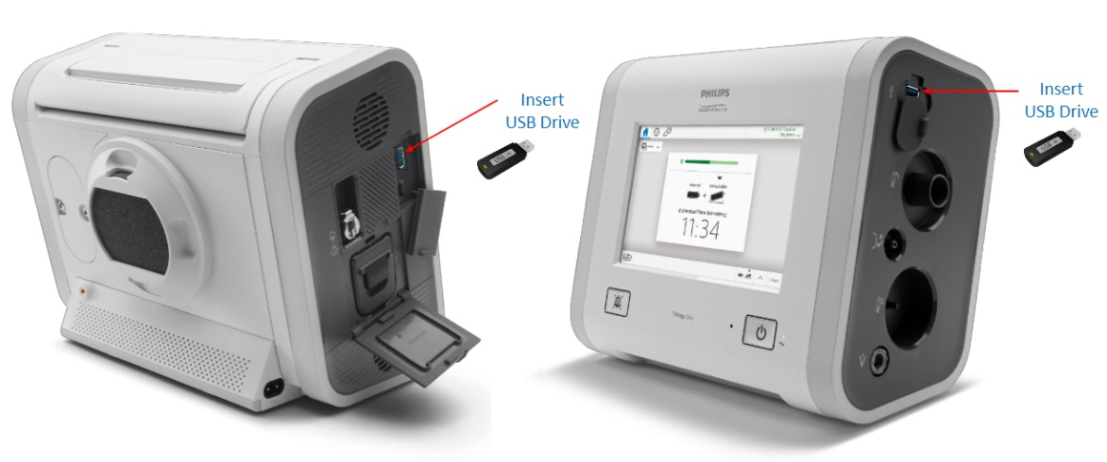

- Go to the OPTIONS window (wrench icon) > Data Transfer

- The device will recognize the USB drive and will show the Software version on the “Install Software Update” box. Click on that box.

- Confirm that you are upgrading the device to the latest version and click YES

- Trilogy Evo is now installing the new software. Please, wait.

- A confirmation of Software installation complete will be shown. Press OK and turn the ventilator ON.

If any issues are encountered when registering your account or downloading the software, please contact Respironics.service.operations@philips.com.

Once the software update has been installed, please ensure you are referring to the latest Instructions for Use and User Manual addendum. As a reminder, the User Manual addendum is provided with this letter.

Appendix E
Software Update Procedure for Hospital Users

To download Software 1.06.10.00 for Hospital users, please access InCenter using the link below
https://philips.mizecx.com/login.html

If you do not have an InCenter account:
- Send an email to PCCI_CS_OPS@philips.com that includes:
- Subject line: Request for access to InCenter Service P&S and Software Downloads for Respiratory Care-Ventilators.
- Customer full name Company/institution
Street address
City, state, postal/zip code
Country
- Telephone number
- Email address
- Ventilator serial number (to confirm that the request is from a valid customer).
Note: The InCenter team processes your request and emails a temporary password to you within 72 hours.

- Once you log into InCenter (https://philips.mizecx.com/login.html), create a password and access technical content for Hospital Respiratory Care products.

- Downloading ventilator software from InCenter
To download ventilator software from InCenter to the service PC, do the following:

- Log on to InCenter: (https://philips.mizecx.com/login.html)

- From the product tree section, select: Hospital Respiratory Care > Ventilation > Trilogy

- Select the Software tab, and then select Software Downloads.

- Select the appropriate software version approved for use in your country.
Note: Please look for Software Version 1.06.10.00 when downloading the software. Read the description to be sure you are permitted to download the particular software revision.

- Downloading Trilogy Evo SW to USB
Note: The USB flash drive cannot contain folders or any other files, only the software file.

- Connect a USB flash drive to the PC. (Minimum memory size should be 2 GB or greater).

- Save the device update zip file to a known location.

- Unzip the file and an .exe file will be available.

- Run the .exe file to self-extract the software update file.

- During the self-extraction, select the USB flash drive location to unzip the file to.

- WinZip will copy the TrilogyEvo.upg file to the USB flash drive. Acknowledge the prompts and close WinZip.

- The USB flash drive will then contain the software update file necessary to update the device software.

- Save the software file to a USB flash drive.

C. Updating the software on your device

- Connect device to AC power. Press On/Off (Standby) button.

- Insert the USB-drive in any of the two USB ports of your device.

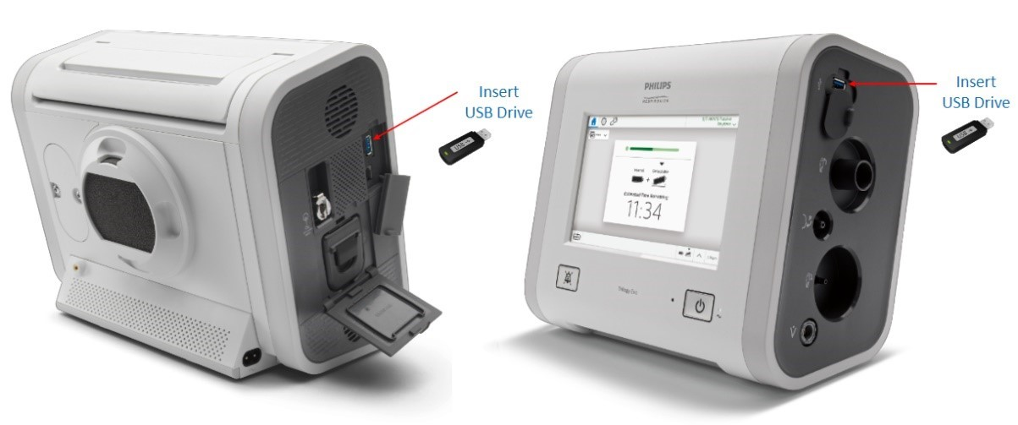

- Go to the OPTIONS window (wrench icon) > Data Transfer

- The device will recognize the USB drive and will show the Software version on the “Install Software Update” box. Click on that box.

- Confirm that you are upgrading the device to the latest version and click YES

- Trilogy Evo is now installing the new software. Please, wait.

- A confirmation of Software installation complete will be shown. Press OK and turn the ventilator ON.

Once the software update has been installed, please ensure you are referring to the latest Instructions for Use and User Manual addendum. As a reminder, the User Manual addendum is provided with this letter.

