Retention Schedule for HR Documentation (PSMC)
The below table is reproduced from appendix 6.iii (Section 6.3.2.3) of the Principal Permanent Secretary Public Service Management Code (PSMC) of June 2018. Categories of documents apply as necessary.

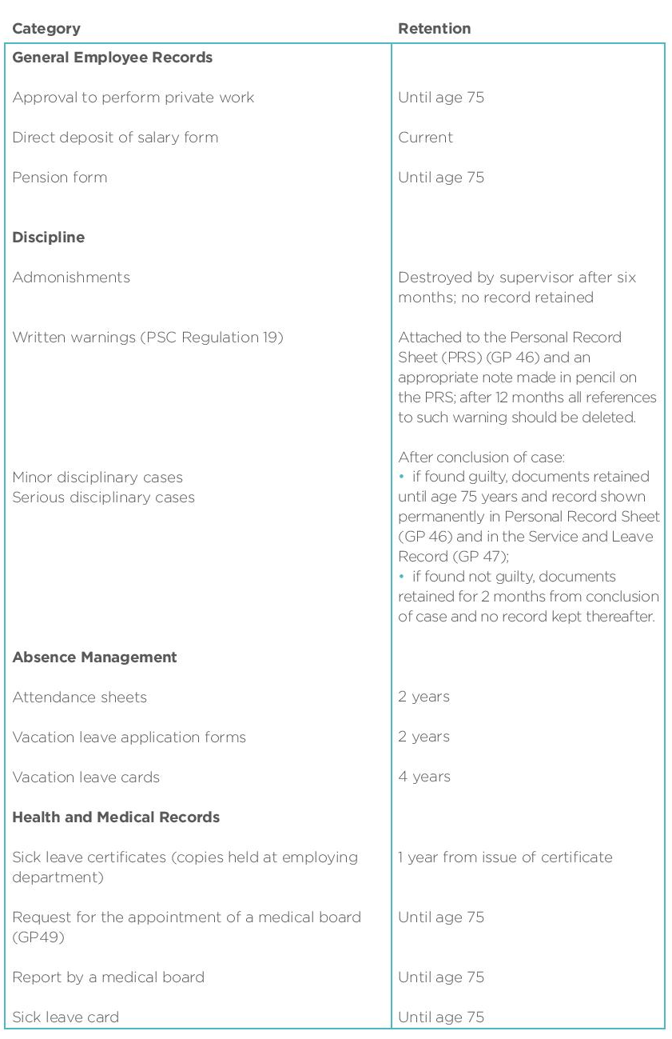

Retention Schedule for Other Documentation (not specified in PSMC)

Quality Record | Details | Owner | Media | Retention Period | Justification for Retention Period | Disposal Method
Complaints logged according to clause 3.5.2 of the policy  P-CO01 | Records as per Policy P-CO01 | Scientific and Regulatory Operations Director | Soft copy | One year after the complaint has been resolved | Internal standard (remit of SROD) | Soft copies - deleted
Inspectorate records on Qualified Person (QP) | Records as defined in the relevant SOPs | Inspectorate and Enforcement Director | Hard and soft copy | Indefinite as per clause 3.11 of Policy P-IN02 | Internal standard (remit of IED) | N/A
Post-Licensing records related to adverse drug reaction (ADR) reporting and Qualified Person (QP-PV) | Records as defined in the relevant SOPs | Post-Licensing Director | Hard and soft copy | ADR reports: Reporter details on ADR form discarded immediately once the ADR is transmitted to Eudra Vigilance.  QP-PV: Indefinitely | Internal standard (remit of PLD) | Hard copies - shredding
Competency records i.e. training records of competence, skills and qualification | Records as per  SOP- HR002 | Scientific and Regulatory Operations Director | Hard and soft copy | 10 years from date of termination of employment | In line with HR Retention Policy - Data Protection Unit (OPM) | Hard copies – shredding; soft copies - deleted
Recruitment Records | Records as per Policy P-HR01 | Scientific and Regulatory Operations Director | Hard and soft copy | 10 years from date of termination of employment. In case of unsuccessful applicants, application documents retained for 1 year after the validity period of the relevant call for applications (unless in the interim, a complaint connected with a particular call for applications has been filed or there is a specific reason). | In line with HR Retention Policy - Data Protection Unit (OPM) | Hard copies – shredding; soft copies - deleted
Travel-related documentation | Travel files as per  P-FCS04 | Scientific and Regulatory Operations Director / Head (Finance and Corporate Services) | Hard and soft copy | 10 years from date of termination of employment | In line with HR Retention Policy - Data Protection Unit (OPM) | Hard copies – shredding; soft copies - deleted
Queries received on accessibility | Records as per policy P-MIA01 | Head (Medicines Intelligence and Access) | Soft copy | 1 year according to clause 3.9 of the policy P-MIA01 | Internal standard (remit of MIAU) | Soft copies - deleted
Declaration of interest forms | Records as per policy P-SS02 | Management | Hard copy | 5 years (unless in the interim, a complaint been filed or there is a specific reason) | Internal standard (remit of SROD) | Hard copies – shredding

